99. Mängu-kontrolltöö

**1.** Värvi murruna avaldatud osa kujundist.

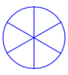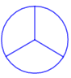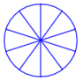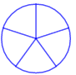a) b) c) d)

   

**2.** Kirjuta värvitud osa suurus murruna.

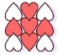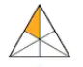a) b) c) d)

|  |
| --- |
|  |
|  |

|  |
| --- |
|  |
|  |

|  |
| --- |
|  |
|  |

|  |
| --- |
|  |
|  |

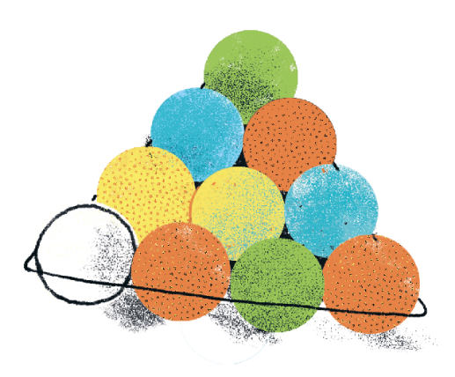**3.** Kirjuta murruna, kui suur osa pildil olevates pallidest on

|  |
| --- |
|  |
|  |

|  |
| --- |
|  |
|  |

a) valged b) värvilised

|  |
| --- |
|  |
|  |

|  |
| --- |
|  |
|  |

c) oranžid d) sinised

**4.** Värvi ja võrdle. Kasuta märke <, = ja >.

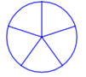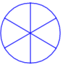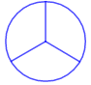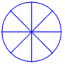a) b) c) d)

       

**5.** Lisa murru osade nimetused ja tähendused.

_____________________________

 ______________________________

______________________________

**6.** Arvuta. Vajaduse korral kasuta joonist.

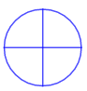 a)  ‒‒ b)  ‒‒ c)  ‒‒ d)  ‒‒



**7.** **Leia** murruga väljendatud **osa** tervikust. Tee iga tehte alla vastav väike joonis.

a)  arvust 21 on _____ b)  arvust 30 on _____ c)  arvust 32 on _____

**8.** **Leia tervik**, kui

a)  sellest on 4; b)  sellest on 3; c)  sellest on 9;

tervik on _____________; tervik on ____________; tervik on ____________.

**9.** Ümber pargi on rajatud kõnnitee.

a) Leia tee kogupikkus, kui  sellest on 200 m.

____________________________________________________________________

Vastus. ______________________________________________________________

b)  sellest kõnniteest on asfalteeritud, ülejäänud plaaditud.

Kui pikk on asfalteeritud teelõik? Vastus. ___________________________________

Kui pikk teelõik on plaaditud? Vastus. _____________________________________

|  |  |  |  |  |  |  |  |  |  |  |  |  |  |  |  |  |  |  |  |
| --- | --- | --- | --- | --- | --- | --- | --- | --- | --- | --- | --- | --- | --- | --- | --- | --- | --- | --- | --- |
|  |  |  |  |  |  |  |  |  |  |  |  |  |  |  |  |  |  |  |  |
|  |  |  |  |  |  |  |  |  |  |  |  |  |  |  |  |  |  |  |  |
|  |  |  |  |  |  |  |  |  |  |  |  |  |  |  |  |  |  |  |  |
|  |  |  |  |  |  |  |  |  |  |  |  |  |  |  |  |  |  |  |  |